Development Log

Links
GitHub: https://github.com/EllenBritton-LeBihan/COMP3000-Computing-Project
Trello: https://trello.com/b/rmv0AVoK/phishnet

Aim and Scope
Train a Machine Learning Model to prevent the subtler phishing attempts in the scenario where two trusted users send and receive emails regularly with each other, and one user has been spoofed.
The product will integrate as an extension with gmail, outlook and/or other emailing platforms.
Audience is for businesses and individuals.

Success Criteria
The overall success criteria will be based on, technical performance, security, usability, business goals, validation and comparison. More details

Technical Performance:
This includes:
- High detection accuracy, achievement of a high true positive rate (TPR) for identifying phishing attempts, with a low False positive rate.
- Adaptability, evolving to new phishing techniques through retraining.
Security:
- Detection of a wide range of spoofing techniques, such as advanced attempts like domain spoofing/style mimicry.
- Privacy preservation in order to ensure user data is handled securely and complies with relevant privacy regulations.
Usability:
- Alerts are user friendly, clear and actionable when phishing attempts detected, they must not overwhelm the users.
Business goals:
- Make the phishing feature appeal to businesses, ensure it meets cybersecurity standards and requirements.

Validation and Comparison:
- Real world testing to validate the model in a live emailing environment. Have feedback loops for continuous improvements.
- Benchmark comparison, outperform existing phishing detection tools on standardised datasets and real scenarios.

- Successfully classify incoming emails into categories (regular, phishing, spam) with reasonable accuracy.
- Flag potentially suspicious emails based on model predictions.
- Enable visualisation of flagged emails in the MailHog web UI for easy review and analysis.

Success Criteria

Semester 1

Sprint 0:
- Initial research on project:
  - Researched papers surrounding the key words “Cyber Security with Machine Learning”, “Machine learning and phishing detection”, “Phishing detection and Cyber security”, etc, to build a picture of what level this topic is currently at to help determine the feasibility of my proposed project. The prevention type in these papers rarely involved a contextual approach within the user emails to prevent phishing attacks. (Areej Alhogail, 2021; Burbela, 2023; Fatima Salahdine, 2022).

  - Email testing and model training environment needed to be decided on. Therefore, further research was done on using APIs as an email testing tool. Comparison of different tools highlighted some requirements:
    - Must be open source,
    - Simplistic and supported at least SMTP.
GreenMail appeared to fit the criteria well, so I began the setup using this.
**However later it proved to cause issues when setting up in Sprint 1, the decision to switch testing tools and use MailHog was made (Further discussed in Sprint 1).

- Technologies and software/tools
  - Python
  - SQLite3
  - GitHub
  - Visual Studio
  - MailHog API
  - Flask

- Write up, Project Initiation
  - Parallel to this stage of information gathering, I worked on putting together the Project Initiation document, submission date October 25th. This entailed project management, (i.e. sprint timelines and scheduling using Gantt chart), the project vision, functional and non-functional requirements and a project risk assessment which will be reviewed again before starting the 2nd semester.
Sprint 0 Learning Curves and or challenges:
Getting a clear overview of the entire project and what will be needed to complete it to fit the requirements. Scheduling and managing the project so that I don’t fall behind, and if I do, then allowing certain sprints which are less busy to be used as some buffer.
Gathering information through reading many research papers surrounding the topic of interest.

Sprint 1
- Implementation of the GreenMail API for Initial email server setup.
  - After setting up and using GreenMail for the initial server and tests sending and receiving emails, I decided to switch to a different email tool since GreenMail is a Java-based and integrate easier with Java projects. As I’m using Python for this project, especially for the machine learning components, I wanted a tool that’s more compatible with Python for smoother development.
  - Part of sprint 1 was delayed due to illness. Therefore, tasks due to be done by Sprint 1 were moved into Sprint 2, refer to Gantt chart to see progress and catchup.

Sprint 1 Learning Curves and or challenges:
Greenmail posed problem integrating with the flask app, several compatibility errors occurred and proved to be too time consuming to warrant continuing with this tool. MailHog was later used and was an easy setup and integration with my Python project.

Sprint 2
Goal: Set up local email env, create synthetic database structure to store email data for testing and model training

Start mail hog server
~docker run -d -p 1025:1025 -p 8025:8025 mailhog/mailhog
~flask run
To trigger send_email route in flask app.py: http://127.0.0.1:5000/send_email
Go to the MailHog endpoint: http://localhost:8025
Usage for MailHog:
Get all emails: GET http://localhost:8025/api/v2/messages
Get a specific email: GET http://localhost:8025/api/v2/messages/<id>
Delete all emails: DELETE http://localhost:8025/api/v2/messages

Setup SMTP server using smtplib and Flask_mail and MailHog for testing purposes.
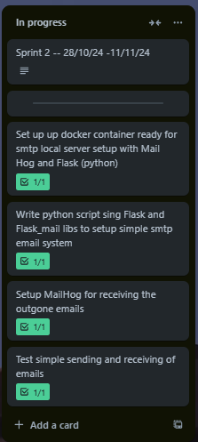
Testing basic email setup with Mail Hog, Docker and Python script using Flask lib TC_001 - PASS
At http://localhost:1025
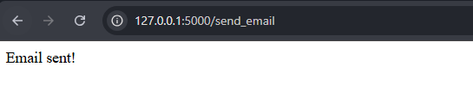

At http://localhost:8025
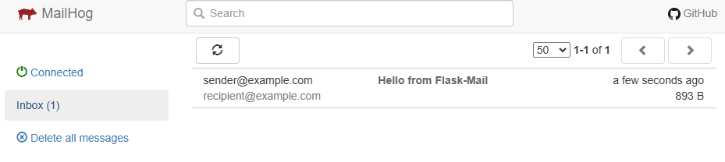

Dataset setup:
Initial email categories:

This is in preparation for training of the ML model so that it can differentiate basics between regular spam, or phishing emails.
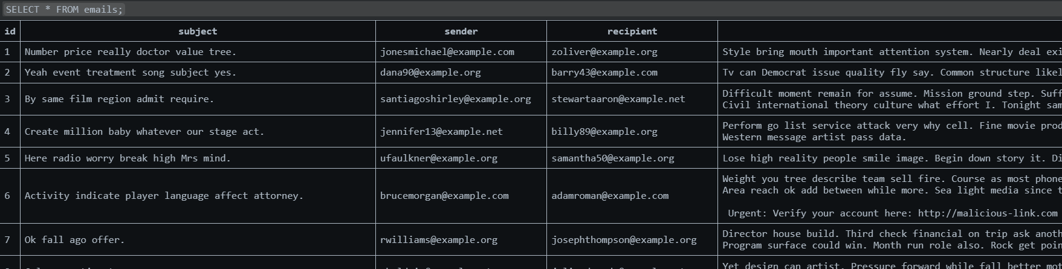
Create a flask route to /send_random_email to send an email randomly from the generated database and view it in MailHog.
To do this, I had to create a new route in app.py:
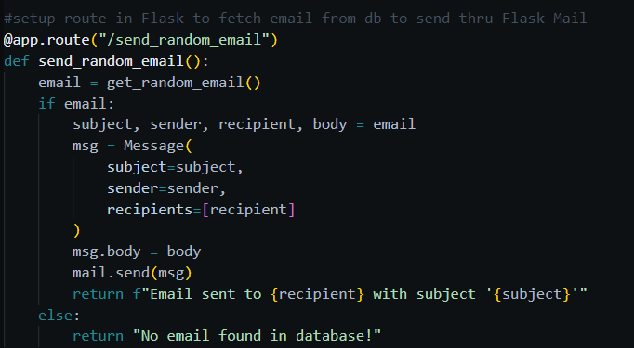
After
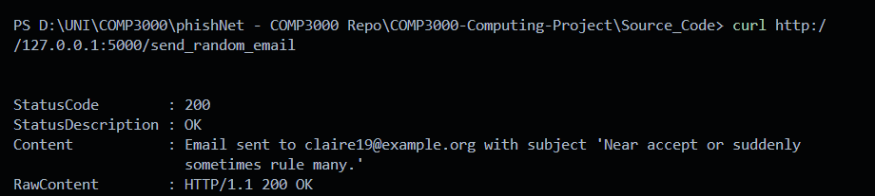

TC_002 PASS

T10 -- Defining a flow of conversation and scenarios a user might have with different contacts.
AIM: identify realistic scenarios and contact types to show different conversation flows exchanges of emails.
PURPOSE: to create natural interactions for ML model to learn typical patterns and detect anomalies.
Common contacts | Description
Family & Friends | Informal, frequent contact, shorter emails.
Colleagues & work | Formal, professional language, attachments, subject focused exchanges.
Service providers | Transactional, concise, can contain clickable links, official language tone.
Phishing scenarios | Mimic trusted contacts but include malicious intent and suspicious elements (urgent language, links to fake sites).

Scenarios for common contacts:
- Regular conversations will have simple exchanges, updates on plans or work updates etc.
- Phishing attempts, entail more urgent messages and unusual requests, fake links.
- Spam are more generic, impersonal language used and often are promotional or unrelated offers.
Python for conversational flow.
Init faker for generating random names, mails, sentences and paragraphs
Define contact and scenario to match each conversation type.
Generate multiple emails in sequence for each contact type to simulate a natural toing and froing of conversation.
TC002.1 to TC002.4 PASS

Sprint 2 Learning Curves and or challenges:
No such challenges to document, Sprint2 went smoothly.

Sprint 3
Tests TC_002.x to TC_003 complete. Focus on making the emails more “realistic” in terms of making sense in sentences and creating dynamic links between sender/recipient and who the name in the salutation and whose name is the sender and signature, aswell as linking the subject title to the category type. I have run into issues with faker, and SQLviewer delaying me by 2 days, I was unable to figure out why I could not view my changes in the templates I created despite code changes and alterations, however this turned out to purely be an issue with the way I had configured my SQL script. This was solved by messing around with some code lines and simply freeing the memory and closing the connection after shutting down the Database. Updates will be as shown on the Gantt Chart. Due to the 5-day delay from illness, I had to push more tasks from sprint 2 into sprint 3 which have now also been delayed, however getting back on track should be straightforward from here on as I have the T10 and T10.1 running smoothly. I also have scheduled buffer time into my project, as we have a 5 week break from other modules over Christmas which I will use to continue working on any backlogged tasks or future tasks to ensure in the event of any further delays it will not cause a problem to the timeline.

Some key changes applied to the email_templates code to make the emails more realistic, were:
- mapping email- to – name, by creating a “sender_email_name_map” and “recipient_email_name_map” a clean way of associating emails with corresponding names dynamically can be developed.
- Using a while loop to make sure the sender and recipient are always different.
- Separate categories so subject lines are drawn from their respective category for clarity.
The changes were successful, some example outputs shown here:
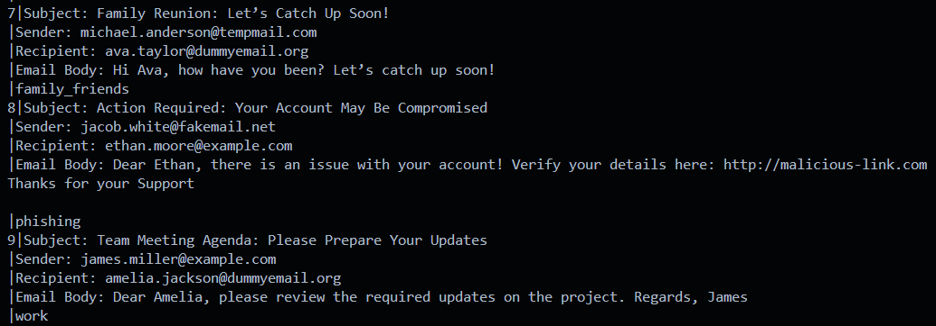
TC_002.6 as described and logged in the test log and test log sheet passed.
Trying the connection between app.py and the database:
Successful attempt. Had to modify the app.py for this to work.
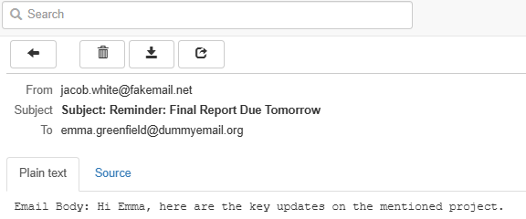
Email returns dynamic names and email addresses which are coherent with sender/receiver. Category is not shown.

The next step is T11
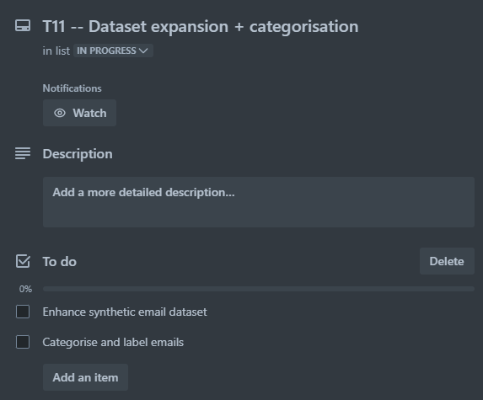
First step is to augment the dataset of emails that is currently setup.
Goal: To expand the dataset to be more representative and varied, will be generating new synthetic emails based on the existing templates with variations.
Step two is to categorise and label the emails into different groups based on their content, there are already three categories (family_friends, work, and phishing). Now these must be assigned either manually or via an algorithmic classification (using ML) to assign categories to new emails.
Step 1: Enhancing the synthetic email dataset.
Generate more emails with modifications, randomise subject lines/sender/recipient names to make dataset more diverse.
Here I have added more body templates, later more first_names and subject data can be added but for now the amount is sufficient for testing purposes.
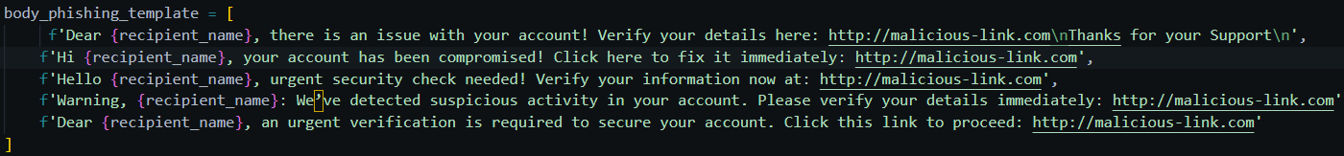
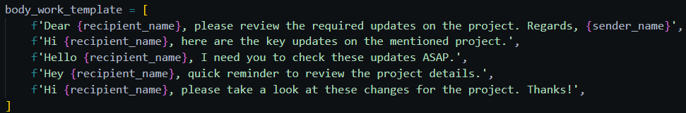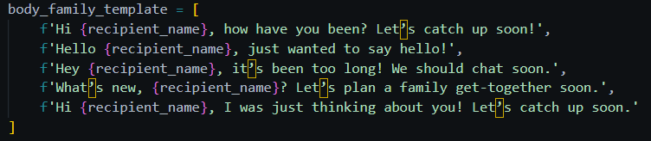

In the next stages of enhancing the dataset before the ML model is to be trained for identifying the difference between phishing and regular emails. This first step requires the features of the phishing problem to be defined and classified:
- Content based features:
  - URLs and Links
  - Presence of IP links
  - Multiple links
  - Attachments
  - Urgent or action-oriented content.
  - Log-in requests
- Metadata features:
  - Discrepancy between display name and email address.
  - Spoofed email addresses (e.g. rnicrosoft.com instead of microsoft.com)
  - Reply-To address (illegitimate emails may redirect replies to a different or unrelated domain).
  - Header features, missing or incorrect headers (e.g. DKIM or SPF records)
  - Sending server (sent from free email providers opposed to organisational servers)
- Contextual and behavioural features:
  - Unexpected context.
  - Unsolicited or Cold emails.
  - Time of sending (odd hours for senders region)
  - Mass mailing patterns.
- Linguistic features
  - Grammar/Spelling errors
  - Overly generic use of language.
  - Unusual tone
  - Inconsistency in branding (Fonts, logos formatting that don’t align with official brand.)
- Visual/Design features:
  - Logo quality (pixelated/outdated)
  - Email design (bad spacing and alignment)
  - Embedded images (clickable images leading to suspicious websites.
- Behavioural/contextual data (Target goal of project to enhance this feature)
  - Unusual sender behaviour
  - Frequency of contact.

There are most probably more features to consider but these will be the main 6 points I will focus on during the training of the model. To be able to accurately implement training, enhancing the dataset further is required to better flag any phishing features. In phishing_template.py the following updates will be included:
- Mismatched display names/email domains
- Suspicious links
- Attachments
- Contextual anomalies
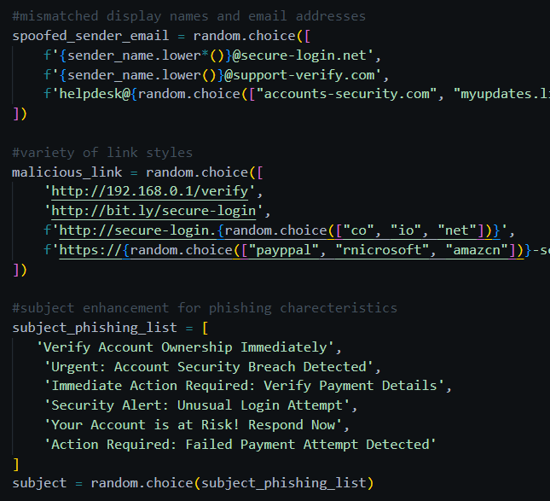
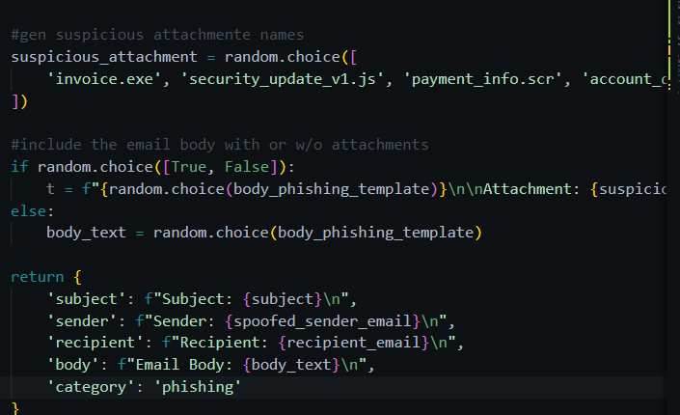
Some changes to the phishing_template
Considerations:
Add more variability and sample size, introduce some random noise such as typos and spacing issues to emulate real world data.

This is the output:
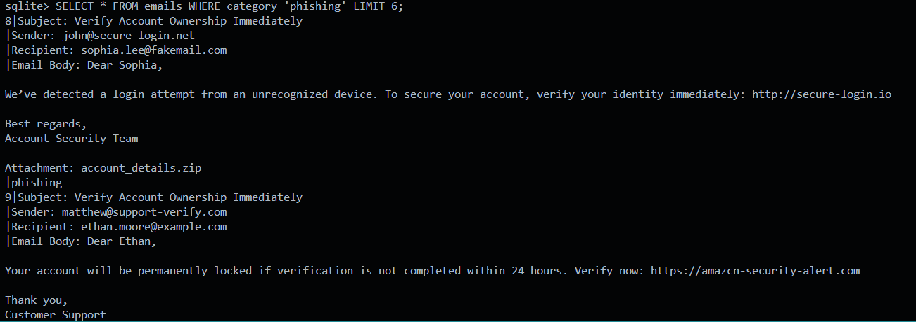

Automatic Categorization: T11
Keyword based categorisation, basing categorisation on certain keywords and phrases in the subject and body of the email.
Keyword association with categories.
“meeting”, “deadline”, “project” = work
“Bank account”, “verify”, “suspicious”, “urgent” = phishing
(be careful about false positives, especially when linking the word bank account with phishing)

Change to file structure as “things” started to become more complex with the email templates and email generation.

Previous structure:
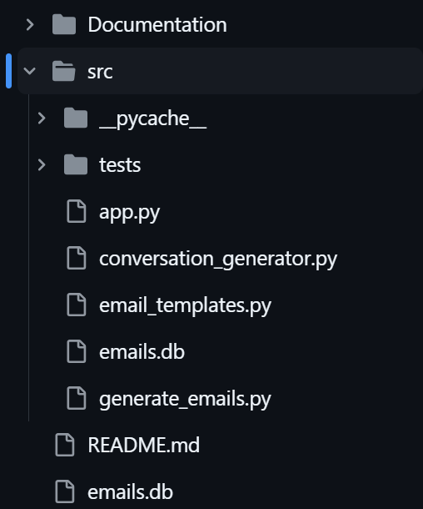
Arranged in no particular way.
To:
src/
+--database
+-- db_utils.py
+--schema.py
+--flask
+-- app.py
+--scripts
+--conversation_generator.py
+--generate_emails.py
+--templates
+--email_templates.py
+--tests
+--manual tests
+--instrument tests
+--unit tests

However, I had to do some research around import module errors, and ensure that I used absolute paths to reference different scripts from one to another

Re-added the spam category: Testing db is populated as should be:
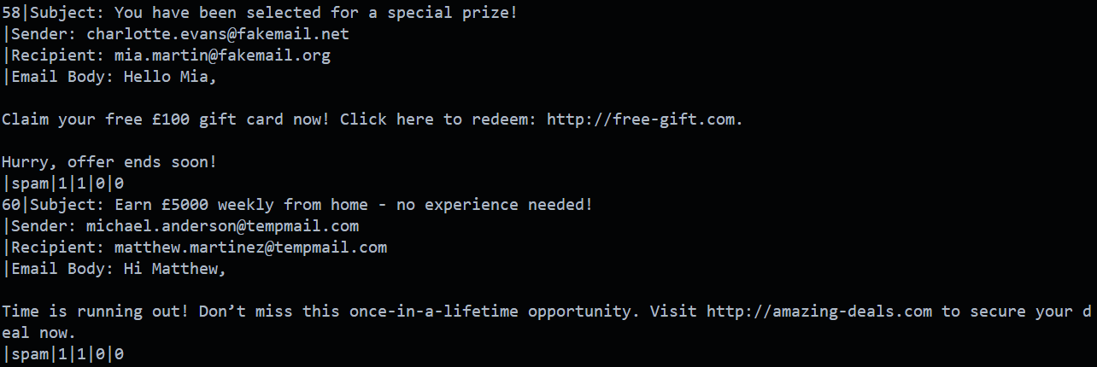
And that emails are received by MailHog as should:
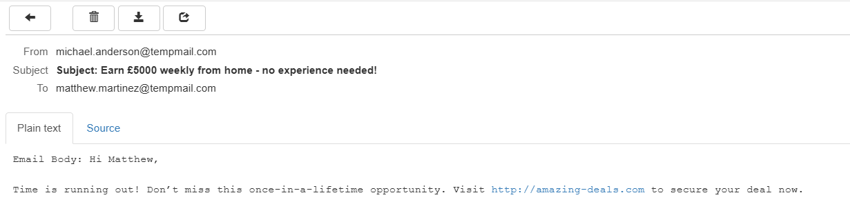
PASS.

Additional changes to differentiate each category further and make the examples more realistic. First, the receiver always has a legitimate domain:
Updated the emails_template to ensure “recipient_email” for all categories is elected based on legitimate domains (example.com, example.net, example.org) by using get_email_by_category(‘family_friends’).
Second, email is category specific: Therefore Family/Work emails use legitimate domains
Phishing/Spam emails use suspicious domains (dummyemail.org, tempmail.com, faikemail.net).
Third, duplicate prevention, ensuring that sender_email and recipient_email are never the same regardless of category.
Enhanced the phishing template. Refined the phishing email body by including a spoofed sender address (e.g. support-verify.com) to add realism, and added malicious links and potential attachments commonly found in phishing attacks.
The benefits of these updates:
1. Trying to mimic real world patterns as best as possible while ensuring logical separation and attempting to retain a basic setup for now in order to make handling data and training easier. Later steps will involve using a different dataset, one which company could then cross check to validate the use of the program.
2. Legitimate targets. Recipients must always be legit.
Improved template simulations to cater for a larger variety of scenarios, whilst still maintaining consistency for training/testing.

At the essence of this project, any phishing attempt will usually include a link (malicious URL) made as bait for a user to click on, other types of bait such as attachments are also used but to begin with only the URLs will be looked at. Therefore, the first thing to establish is how to identify these malicious URLs within an email. Leading to the Problem.
Problem: how to differentiate legitimate URLs to non-malicious URLs.
First question, what are malicious URLs?
- Crafted hyperlinks with the intention to manipulate and trick users. They can:
  - Redirect to phishing websites to steal sensitive data.
  - Host malware or other malicious payloads.
  - Appear legitimate but direct users to unintended, harmful destinations.
Second question, what types of machine learning are suitable to detect these URLs?
- The issue of malicious URL detection is generally approached using supervised learning techniques, where data is labelled and pre-established for training models. Suitable ML approaches will include:
  - Support Vector Machines (SVMs): Good for high dimensional datasets.
  - K-Nearest Neighbours (KNNs): Simple but can be computationally expensive for large datasets.
  - Random Forests (RFs): Offers robustness and reasonable accuracy.
Third question, what are the metrics for evaluating models?
The best method for malicious URL detection needs to be determined. This will be based on the following metrics:
- Accuracy:
  - Measure of how overall correct the predictions are.
  - Formula:
  - Advantages: Gives a general idea of the model’s performance.
  - Disadvantages: Can mislead imbalanced datasets.
- Precision (Positive Predictive Value)
  - Focuses on how many predicted malicious URLs are actually malicious.
  - Formula:
  - Use Case: Import when the cost of false positives is high.
- Recall (sensitivity/true positive rate)
  - Measures the number of actual malicious URLs are correctly identified.
  - Formula:
  - Use case: Crucial whenever missing malicious URLs (false negatives) is costly.
- F1-Score
  - The harmonic mean of precision and recall, giving a balanced measure.
  - Formula:
  - Use case: Is useful for imbalanced datasets, when precision and recall need to be balanced.
- ROC-AUC (Receiver Operating Characteristic – Area Under Curve)
  - This evaluates the trade off between true positive and false positive rates.
  - Use case: Gives insight to model performance over different thresholds.
- Log Loss (Cross-Entropy loss)
  - Measures uncertainty of the model’s predictions.

  - Use case: Helps to understand how confident the model is about its own predictions.
- Execution time and computational cost.
  - Measure of time taken to train and test model.
  - Use Case: Is relevant for deployment and also scalability.
Fourth question, what are the steps to differentiate legitimate and malicious URLs?
- Feature extraction relevant to URLs:
  - Lexical features.
  - Host-based
  - Content
  - Behavioural
- Dataset Preparation: Labelled dataset for training:
  - Maybe move onto open-source datasets ? Perhaps this is the best route to go forward ?
  - Augmented with real URL data.
- Model, training and tuning:
  - Train SVMs, DTs, KNNs, and RFs. Tune hyperparameters using methods such as Grid search or Random Search.
- Evaluation and Comparison:
  - Use the metrics to determine the most effective model.

Consideration into whether a synthetic dataset or open-source dataset has been debated and concluded on combining both methods to create the most accurate possible representation of attack patterns. During the process of untangling the problem for URL differentiation, I have come to realise that the ML model needs to initially understand what a harmful link is and how to detect it. Next steps are what do suspicious email address look like, then it can scan for strange server locations and routes, and finally the contextual behaviours of emails between users to give a more personalised and detailed understanding of some

Content based features and patters in emails to check:
- Sender reputation:
  - Spoofed email address? – Block
  - Know bad actor: -- Block
- Authentication Failures, likely spoofed:
  - Failure of SPF, DKIM and DMARC. – Block
- Sender’s domain:
  - Newly registered: -- Scrutinise, Flag
  - Non-matching domains? – Flag
- Geographical mismatch:
  - Flag
- Bulk sending: -- flag as spam
- Generic addressing: -- Flag
- Phishing Links: Block
- Redirection: Block
- Suspicious attachments: Block
- Hidden HTML features:
  - Invisible text: -- Block
  - Base64 encoding: -- Block
  - Embedded javascript or other scripts: -- block
  - Excessive images: -- Flag
  - Unusual Email structure: -- Flag
  - Different reply-to mismatch: Flag
- Low engagement: -- move to a spam folder.
Malicious hyperlinks? – block opening and alert.
Suspicious attachments? – Block opening and alert
Subject, red flag? – Flag
Suspicious HTML features? - Flag
Blacklisted Sender address? - Block
Unknown or new senders? – Scrutinise closely
Not compliant with SPF, DKIM, or DMAC? – Block
Senders email address has formatting issues. - Flag
High volume senders. Mark spam
Geographically unusual or unexpected regions for sender. Flag
Bulk sending. Mark spam
User interaction low: Mark spam

After breaking down the methods and steps needed to differentiate the malicious and on malicious links, I came to realise that whilst learning and untangling the initial stages in sprints 1, 2 and part way 3, I have put more focus into the whole vision, i.e. seeing the phishing detection tool is an all-encompassing extension to alert and prevent phishing attempt. However, what sets aside my project to other phishing detection tools is its consideration for pattern and behaviour recognition between trusted users and its ability to flag the potential for phishing attempts when anomalies occur. Therefore, I have re-directed and set myself back on track to better align with my aim and end goal, which is defined in the “Aim and Scope” section. I will be isolating the situation specifically to the scenario of two trusted users which regularly exchange emails and one of the users has been spoofed by a malicious actor. For this I will be using the enron dataset since this can be easier compared and benchmarked later on. It also contains 0.5M email conversations which makes it ideal for machine learning training.

T12 – feature extraction using enron dataset
Train a Machine Learning Model to prevent the subtler phishing attempts in the scenario where two trusted users send and receive emails regularly with each other, and one user has been spoofed.

24h Nov research enron dataset.
25th Nov Download/Extract dataset, Extract Sender-Receiver Pairs
26th Nov --

Step 1 for isolated scenario setup.
Find open source dataset. – Kaggle ?
Step 2. Extract relevant emails to create conversation chains that resemble trusted user exchanges.
Step 3. Inject phishing email samples with spoofed identities, crafted to closely resemble trusted users. Modify legitimate emails to create subtle phishing emails.
Step 4. Label the data, assign 0 for legit and 1 for phishing, ensure balanced representation of both the classes.

Step 5. Prepare the data for training. Feature engineering to extract features relevant to phishing detection like:
Sender domain, reply-to address, SPF/DKIM/DMARC status.
Content features: Links, attachment presence, phishing leywords and language style.
Behavioural features, frequency of communication between the users.
Tokenize and vectorise email content using embeddings, normalise header and meta data features.
Split the data set into training and validation and test sets to ensure robust evaluation.
Step 6: Integrate with the flask app, and mailhog.
Use flask to send simulated emails (both legit and phish) through API Mailhog to test and visualise.
Connect the model to monitor any incoming emails through mailhog api, flagging potential phishing attmpts.
Use flask routes to test the model by generating dynamic phishing scenarios, which helps to validate the model in real life conditions.
Step 7. Evaluate and benchmark, use the metrics to evaluate the model.
Compare the tool performance with existing phishing detection tools using standardised datasets.
Can combine public datasets and scenario specific augmentation with flask environment to create pipeline specific the the project goals.
Step 8. Repeat with other supervised learning models and compare results.

Sprint 3 Learning Curves and or challenges:

Sprint 4
This is an overview of what sprint 4 looks like so far. Since the beginning of this sprint, I have been learning methods and theory on how machine learning works, and on how to execute it using python in order for me to get my MVP up and running.
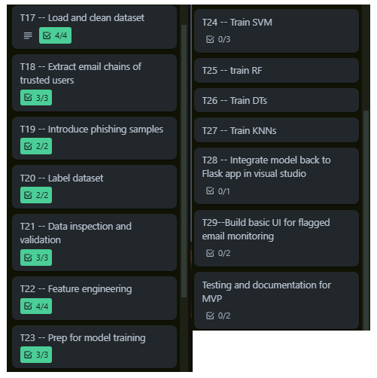

Currently I am training the SVM. Here are the results.
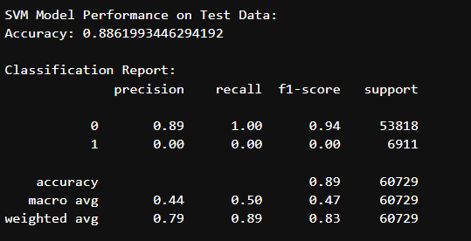
Interpretation of results:
- Accuracy = 88.62%, the model correctly predicted target variable 88.62% of the time.
- Classification report:
  - Precision (Class 0) 0.89, indicates when model predicted class 0 (spam) it was correct 89% of the time, Therefore, class 0 predictions are quite reliable.
  - Recall (Class 0) 1.00, shows model identifies correctly all true instances of class 0. No false negatives.
  - F1-Score (Class 0) 0.94, harmonic mean of precision and recall, strong performance for class 0.
  - Precision (Class 1) 0.00, model fails to predict any true instances of class 1
  - Recall (Class 1) 0.00, the model did not identify any true instances of class 1
  - F1-Score (class 1) 0.00
In conclusion, it looks like the model is ignoring the Class0 .
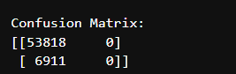
The confusion matrix tells us of True negatives and false positives, we can see that:
[53818 0] for class 0 gives 53818 correct predictions, and 0 false positives.
[6911 0] for class 1 gives 6911 false negatives and 0 true positives.
So essentially the model is not predicting any instances of class 1. Its very biased toward predicting class 0 and fails to identify class 1 at all. The high accuracy scores are driven by the higher number of class 0 instances; therefore, this metric doesn’t provide an accurate reflection of the model’s performance over both classes, especially in an imbalanced dataset.
First thing to ensure is that there are no missing values in the dataset
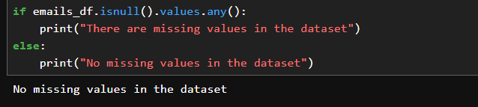
Which there are not.
Now I can move forward with finding a solution.

Sprint 4 Learning Curves and or challenges:

Semester 2

Sprint 5
Sprint 5 Learning Curves and or challenges:

Sprint 6
Sprint 6 Learning Curves and or challenges:

Sprint 7
Sprint 7 Learning Curves and or challenges:

Sprint 8
Sprint 8 Learning Curves and or challenges:

Sprint 9
Sprint 9 Learning Curves and or challenges:

Sprint 10
Sprint 10 Learning Curves and or challenges:

References

Areej Alhogail, A. A. (2021) Applying machine learning and natural language processing to detect phishing email. Saudi Arabia: Information Systems Department, College of Computer and Information Sciences, King Saud University, Saudi Arabia. Available at: https://www.sciencedirect.com/science/article/abs/pii/S0167404821002388#:~:text=The%20classifier%20was%20tested%20in,false%2Dpositive%20rate%20of%200.015. (Accessed: 04/10/24).

Burbela, K. (2023) Model of detection of phishing URLs
based on machine learning. Karlskrona, Sweden: Faculty of Computing, Blekinge Institute of Technologyy. 40 pp. Available at: https://www.diva-portal.org/smash/get/diva2:1773760/FULLTEXT02 (Accessed: 04/10/24).

Fatima Salahdine, Z. E. M., Naima Kaabouch (2022) Phishing Attacks Detection
A Machine Learning-Based Approach. North Dakota Grand Forks: 1
School of Electrical Engineering & Computer Sciences, University of North Dakota
Grand Forks, ND-58203, USA, Department of Electrical and Computer Engineering, the University of North Carolina at Charlotte,
Charlotte, NC-28223, USA. 6 pp. Available at: https://arxiv.org/pdf/2201.10752 (Accessed: 04/10/24).

